
THE CHINESE UNIVERSITY

OF HONG KONG (SHENZHEN)

School of Science and Engineering

Tutorial - 12

Fundamental of Artificial Intelligence CSC3180

- Answer the following questions:

- Why deep learning (DL)? What difference between ANN and DL? (L13: P4-6)
- Compared with Machine Learning (ML), what is the main characteristics? (L13: P7-8)
- Please understand DL process and its feature analysis. (L13: P9-10)
- What about two problems of Depth. (L13: P28-29)
- What’s the key points of Convolution Networks? Please list them out and give one or two techniques for each key point. (L13: P31-33)
- Why the locally connected NNs are better than fully connected NNs? (L13: P34-35)
- Why the shared weights method is useful in ANN design? (L13: P36)
- Why pooling layer? Please explain two main approaches, Max pooling and Average pooling. (L13: P40-41)
- What is Receptive Field? What difference between receptive field of pooling and convolution? (L13: P42-45)
- There are three activation functions, Sigmoid, Tanh and ReLU. Why ReLU is widely adapted in DL? (L13: P46)
- Please understand Loss layer: Softmax and its three optimization approaches. (L13: P51-56)

Now, if given a dataset with two classes of image. We want to take use of deep learning to solve the classification problem. Please answer the following Question 2 to 5.
N
- Currently, we have only 2,000 images for training. It’s not enough to train a convolution network. Thus, enlarging the dataset is needed. Let’s set the image size is 64×64. In order to keep most part of the image, the minimum input image size of the network is 56×56. Please use crop and mirror to do data argument.
- Describe the crop and mirror method.
- Calculate the total number of training samples after argument.
- Given a small image with the size of 4×4, please first crop the image to 3×3 patches and then mirror the cropped patches.
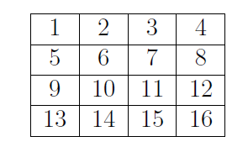
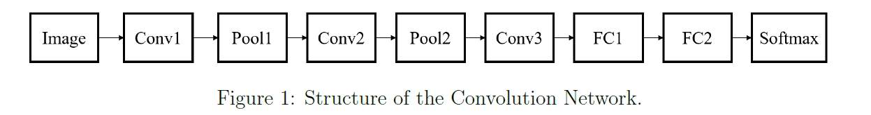
The input image size for classification is 56×56 after enlargement. Now, we have designed a convolution network for this classification problem in Figure 1. Conv1 do 3×3 convolution with 64 filters without padding. Pool1 do 3×3 max pooling. Conv2 do 7×7 convolution with 128 filters without padding. Pool2 do 2×2 max pooling. Conv3 do 5×5 convolution with 128 filters and zero-padding, pad 1. FC1 has 512 neurons and FC2 has 2 neurons. Conv1, Conv2, Conv3 and FC1 is followed by a ReLU activation.

- Now calculate the following problem.
- Calculate the size of the output of each layer (height×width×channel).
- Calculate the number of parameters of Conv2.
- Figure 2 gives the output of Conv2 before ReLU. Please calculate the results after ReLU and Pool2.
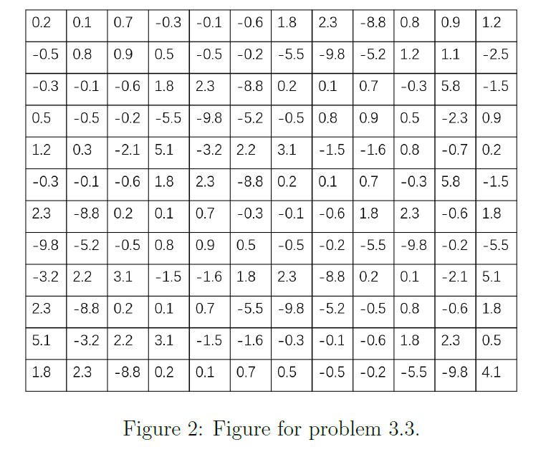

- Calculate the receptive filed of Conv1, Pool1, Conv2, Pool2 and Conv3.

- Describe the steps of designing a Convolution Network to solve a classification problem.

